Minor Project Proposal on

**STUDY ROOM: e-learning QA Module**

Submitted in partial fulfillment of the requirements for the degree of

**Bachelors of Engineering in Information Technology**

under Pokhara University

Submitted by:

**Abhinav Paudel, 15449**

**Mandeep Panta, 15464**

**Ashbin Thapa, 15455**

Date:

22nd FEB 2023

**Department of Information Technology**

**NEPAL COLLEGE OF**

**INFORMATION TECHNOLOGY**

Balkumari, Lalitpur, Nepal

**ABSTRACT**

*This project serves as a platform where developers can ask and answer technical questions related to programming, software development, and other technology-related topics.*

*The platform operates on a user-generated content model, where users can ask questions and provide answers. Users can also add comments, and participate in discussions on a wide range of technical topics. The platform hosts a vast collection of user-generated content, ranging from specific coding issues to broader software development concepts.*

*The projects serve to provide a platform for knowledge exchange, where developers can ask and answer technical questions related to programming, software development, and other technology-related topics. The platform aims to facilitate the exchange of knowledge and ideas, promote best practices, and help developers find solutions to technical challenges.*

*This project is based on Python and Django framework, Bootstrap, HTML and CSS. A website that allows a user to inquire about their problems about coding and many software programming related queries and post solutions to them.*

Keywords: Knowledge Exchange, Study materials, Study Platform

Contents

**1.** **INTRODUCTION** 1

1.1. PROBLEM STATEMENT 1

1.2. OBJECTIVES 1

1.3. PROJECT SCOPE AND LIMITATIONS 2

1.3.1. SCOPE 2

1.3.2. LIMITATIONS 2

1.4. SIGNIFICANCE OF STUDY 2

2.1. PREVIOUS SIMILAR WORKS 3

**3.** **METHODOLOGY** 5

3.1. SOFTWARE DEVELOPMENT LIFE CYCLE 5

3.1.1. REQUIREMENT PHASE 6

3.1.2. ANALYSIS AND DESIGN PHASE 6

3.1.3. IMPLEMENTATION 6

3.1.4. TESTING 6

3.1.5. EVALUATION 6

3.2. WHY ITERATIVE MODEL? 6

3.3. TOOLS USED 7

3.4. TECHNOLOGIES 7

**4.** **PROJECT PERFORMANCE ANALYSIS METHODOLOGY** 8

**5.** **PROPOSE DELIVERABLES** 10

**6.** **PROJECT TASK AND TIME SCHEDULE** 11

6.1. GANTT CHART 12

**7.** **REFERENCE** 13

**LIST OF TABLES**

Table 1: Tools used 7

Table 2: Project Task and Time Schedule 8

**LIST OF FIGURES**

Figure 1: Iterative model of software development life cycle 5

Figure 2: Gantt Chart 12

# 

# **INTRODUCTION**

Study Room is a question and answers website for programmers. This web application will be the platform where developers can ask and answer technical questions related to programming, software development, and other technology-related topics.

The platform operates on a user-generated content model, where users can ask questions and provide answers. Users can also add comments, and participate in discussions on a wide range of technical topics. The platform hosts a vast collection of user-generated content, ranging from specific coding issues to broader software development concepts.

## PROBLEM STATEMENT

Study Room is a website that hosts a community of programmers and developers who ask and answer questions about programming-related topics. As such, a problem statement for Study Room would be:

"How can I solve a specific programming issue or error that I am encountering in my code? I am seeking help from the Study Room community to find a solution or a better way to approach my problem."

The problem statement should include details about the specific issue or error, the programming language or technology being used, and any relevant code or examples to help others understand the problem. Additionally, it should convey a willingness to learn and a desire to collaborate with others in finding a solution.

## OBJECTIVES

The drawbacks mentioned in problem statements need to be solved, for which a new and easier method for a learning needs to be derived. Study Room : e-learning class module is such an web application where the users can present their queries and receive answers from the others users. Following are the objectives of this project:

1. To develop web application for asking and answering the questions related to various faculties.
2. Help to build learning community.
3. Develop an interactive web application with user friendly search interface.
4. To allow people to communicate to increase flow of information among them.

## PROJECT SCOPE AND LIMITATIONS

The scope of this project is to provide user with all the services through an web service. In this project, an web application will be developed where users will be able to ask and answer questions.

### SCOPE

1. The targeted people are programmers and developers.
2. This web application can be modified and used for various college/school or even universities.

### LIMITATIONS

1. This is only website not a app.
2. This web application is mainly focus to developers.

## SIGNIFICANCE OF STUDY

This project is proposed with the intention to develop an Web Application of the QA platform where users can ask the questions of their concern and obtain answers from other users. The existing platform provides the QA platform however this project will have some additional features regarding the study materials and chat feature. So this project is meant for providing user friendly web application in efficient way.

1. **LITERATURE REVIEW**

## PREVIOUS SIMILAR WORKS

**Quora** is a Q&A platform that empowers people to share and grow the world’s knowledge. People come to Quora to ask questions about any subject, read high quality knowledge that's personalized and relevant to them, and share their own knowledge with others. Quora is a place to share knowledge and better understand the world. [5]

**Pros**

* In Quora application you just not become a good reader but also becomes a good writer. [6]
* It always finds very effective answer for your questions which is written on the basis of true experience and event. [6]
* An additional feature here is that you can create your own blog, group where you can share articles and lift up your and others’ life. [6]

**Cons**

* There is no service to search inside this answers. [4]
* Sometimes get comment without notification about it. [4]
* There is no option to prevent flow of answer request from people that are not follow. [4]

**Stack overflow** is a network of [question-and-answer websites](https://en.wikipedia.org/wiki/Comparison_of_Q%26A_sites) on topics in diverse fields to enable users to post questions and answer them. Users can vote on both answers and questions, and through this process users earn reputation points. Users can also add comments to the questions and answers, as well as, edit text written by others. [2]

**Pros**

* It helps to ask questions, get answers, no distractions. [2]
* Tags make it easy to find interesting questions. [2]
* You earn reputation when people vote on your posts. [2]

**Cons**

* The web page blocked user if they didn’t have enough reputation as a new user . [7]
* Its biggest weakness is that it is not a very good platform for facilitating discussions. [7]
* Its second biggest weakness is the unbalanced reputation system. [7]

**Yahoo Answers** is one of the most popular Quora alternatives.  It’s free to sign up for, and includes a sort of “game” system where you gain points for answering other people’s questions.  This increases the number of questions that you can ask or answer per day. [3]

**Pros**

* You are able to ask any question. [1]
* You are able to get any answer, whether it’s the best or the worst. [1]

**Cons**

* Yahoo Answers isn’t quite as professional or heavily-moderated . [3]
* Certain questions may be poorly formed or trivial, and answers may not necessarily correct. [3]
* There is often a limited amount of time to answer a question. [3]

# **METHODOLOGY**

In this section we have described about the method that we will be using to meet the requirement of the project.

## SOFTWARE DEVELOPMENT LIFE CYCLE

The model to be used for developing of this project is Iterative model of SDLC. Iterative model is simple and emphasizes on initial and simple implementation and with progress in the project it gains more feature. It is advantageous since it has unique feature of repetitive nature i.e. during development phase one can go back to check out the previous works without any complications and flaws can be improved if any. Further explanation about the model has been described below.

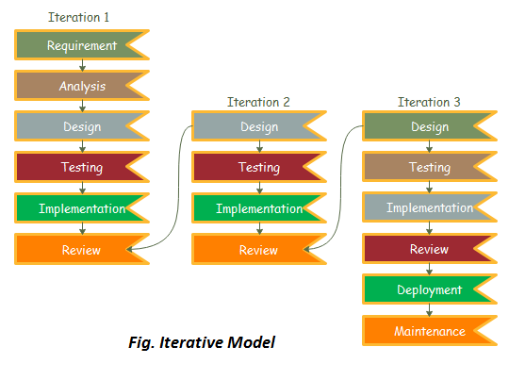

Figure : Iterative model of software development life cycle

### REQUIREMENT PHASE

In this phase, all the necessary requirements are analysed. Till now necessary requirement for further analysis of project is gathered from end-user, Internet and teachers. And as a result, final specification of the project will be gained.

### ANALYSIS AND DESIGN PHASE

In this phase, the specification gathered is designed as per the requirement. Further the database models, technical requirement and the logic will be implemented in the project.

### IMPLEMENTATION

After the analysis and design the coding is done according to the specifications. Coding is in progress and hence a working system will be obtained in this phase.

### TESTING

Once a system is developed series of testing will be performed in order to remove bugs and errors. Also, in this phase certain changes, if necessary, will also be applied to obtain complete and successful system.

### EVALUATION

Evaluation is the last step performed after all the prior steps, where the project will be evaluated to check if it meets the specification or not.

## WHY ITERATIVE MODEL?

Requirements can be changed if necessary by going back to the previous phases without any effect to the further ongoing process.

## TOOLS USED

|  |  |
| --- | --- |
| TOOLS | PURPOSE |
| Python | Whole application base creation platform |
| Github | To manage Source Code |
| Adobe Photoshop CS6 | Logo Design |
| Django | Framework of Python used to create web applications. |
| Android device | For Testing |

Table 1: Tools used

## TECHNOLOGIES

* Operating system: Windows 8/10/11.
* Python Programming language.
* Django framework for the development of backend.
* HTML, CSS.
* Sqlite3, for database.
* Web Browser.

# **PROJECT PERFORMANCE ANALYSIS METHODOLOGY**

Project Performance Analysis Methodology:

Define metrics: The first step in analyzing the performance of a question-answer web application is to define the metrics that will be used to measure its performance. This may include metrics such as response time, uptime, number of users, user engagement, and conversion rates.

Collect data: Once the metrics have been defined, data should be collected on a regular basis to measure the application's performance. This may involve using tools such as Google Analytics, server logs, or custom tracking scripts.

Identify areas for improvement: Based on the analysis, areas for improvement should be identified and prioritized. This may involve addressing performance bottlenecks, improving user experience, or increasing engagement and retention.

Implement changes: Once the areas for improvement have been identified, changes should be implemented to improve the application's performance. This may involve optimizing code, improving server infrastructure, or adding new features to enhance user experience.

Monitor progress: After implementing changes, the application's performance should be monitored to ensure that the changes have had the desired effect. If necessary, additional changes may need to be made to further improve performance.

Validation Scheme:

User testing: One of the most important validation schemes for a question-answer web application is user testing. This involves recruiting a group of users to test the application and provide feedback on its usability, functionality, and overall user experience.

Code reviews: Code reviews can help to validate the quality of the application's code and identify potential bugs or issues that may impact performance or user experience.

Functional testing: Functional testing involves testing the application's features and functionality to ensure that they work as intended and meet user needs.

Usability testing: Usability testing involves testing the application's user interface and user experience to ensure that it is easy to use for a wide range of users.

Overall, the validation scheme for a question-answer web application should involve a variety of testing and evaluation methods to ensure that it is robust, user-friendly, and performs well under a range of conditions.

# **PROPOSE DELIVERABLES**

The purpose of a question-answer web application is to provide a platform for users to ask and answer questions related to a variety of topics. User registration and authentication: The application should allow users to register and create accounts, as well as log in using their credentials. Question and answer posting: Users should be able to post questions, which can then be viewed and answered by other users. The application should also allow for the posting of answers to existing questions. Search functionality: The application should include a search feature that allows users to find questions and answers based on specific keywords or phrases. User profile management: Users should be able to manage their profiles, including updating their personal information. Overall, the primary goal of a question-answer web application is to provide a user-friendly and efficient platform for users to ask and answer questions, share knowledge and information, and engage with a community of like-minded individuals.

# **PROJECT TASK AND TIME SCHEDULE**

The project schedule has been designed as per requirements of the project. Various tasks have been enlisted in the table as per the requirements. Debugging and testing is to be done prior to the completion of the project. Similarly, approximate duration has been scheduled as per the tasks.

|  |  |
| --- | --- |
| **TASK** | **APPROX** **DURATION IN DAYS** |
|  |  |
| Requirements analysis and specification | 25 |
|  |  |
| Under take analysis of the system | 28 |
|  |  |
| Design system | 72 |
|  |  |
| Produce Requirements specification | 39 |
|  |  |
| Testing and debugging | 28 |
|  |  |
| Test system modules | 20 |
|  |  |
| Overall system test | 22 |
|  |  |
| Develop Documents | 56 |
|  |  |

Table 3: Project Task and Time Schedule

## GANTT CHART

The Gantt chart below has been constructed on the basis of the above project schedule. According to the table the project is estimated to be completed in 3 months. The task is started from preliminary investigations and the other tasks are scheduled in accordance.

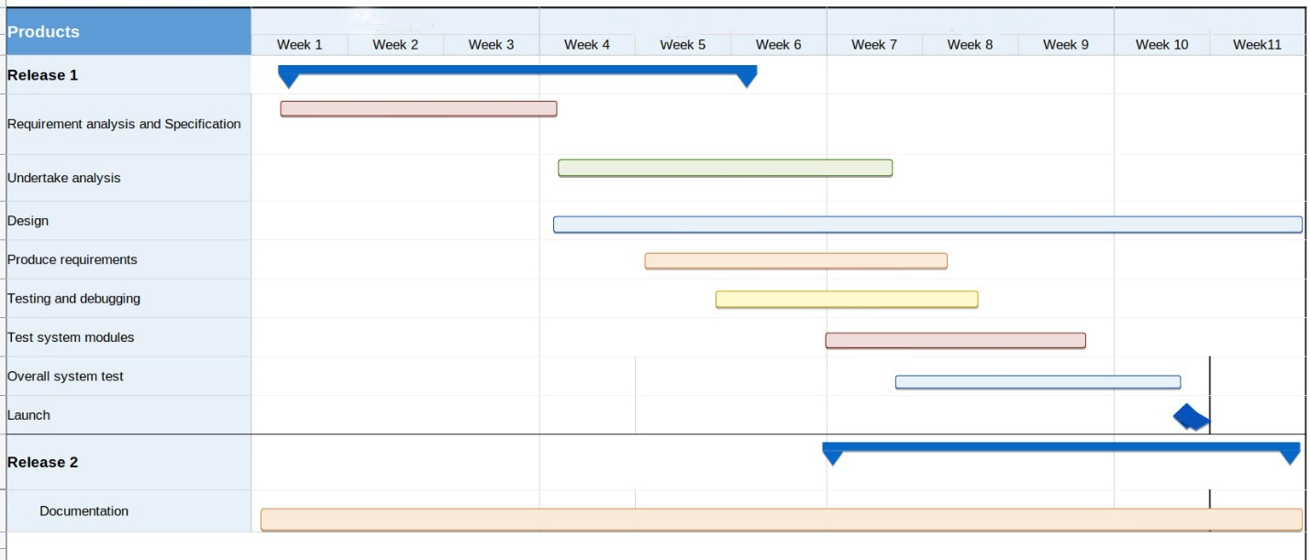

Figure 2: Gantt Chart

# **REFERENCE**

1. ( **Reger S. Pressman, Ph.D. Seventh** Edition, Software Engineering: A Practitioner’s Approach, McGraw Hill, 2010
2. Beginner Python Tutorial Available : [https://www.w3schools.com/python/](http://www.homeandlearn.co.uk/python/php.html)
3. **The Python Language Reference Manual** (version 2.5) by Guido van Rossum, and Fred L.

Drake, Jr. (Editor)

1. Quora. (2019, Nov 8). *About us*. Retrieved from Quora — Questions, Answers, and More: https://play.google.com/store/apps/details?id=com.quora.android&hl=en
2. Sharma, S. (2018, May 22). *Quora*. Retrieved from What is the Quora app?: https://www.quora.com/What-is-the-Quora-app
3. *Stack overflow*. (2019, jan 14). Retrieved from why i refuse stackoverflow?: https://www.sitepoint.com/community/t/why-i-refuse-to-use-stackoverflow/38483/10
4. Stack Overflow. (2019, Mar). *Stack Overflow's Features*. Retrieved from Stack Overflow: https://stackshare.io/stack-overflow